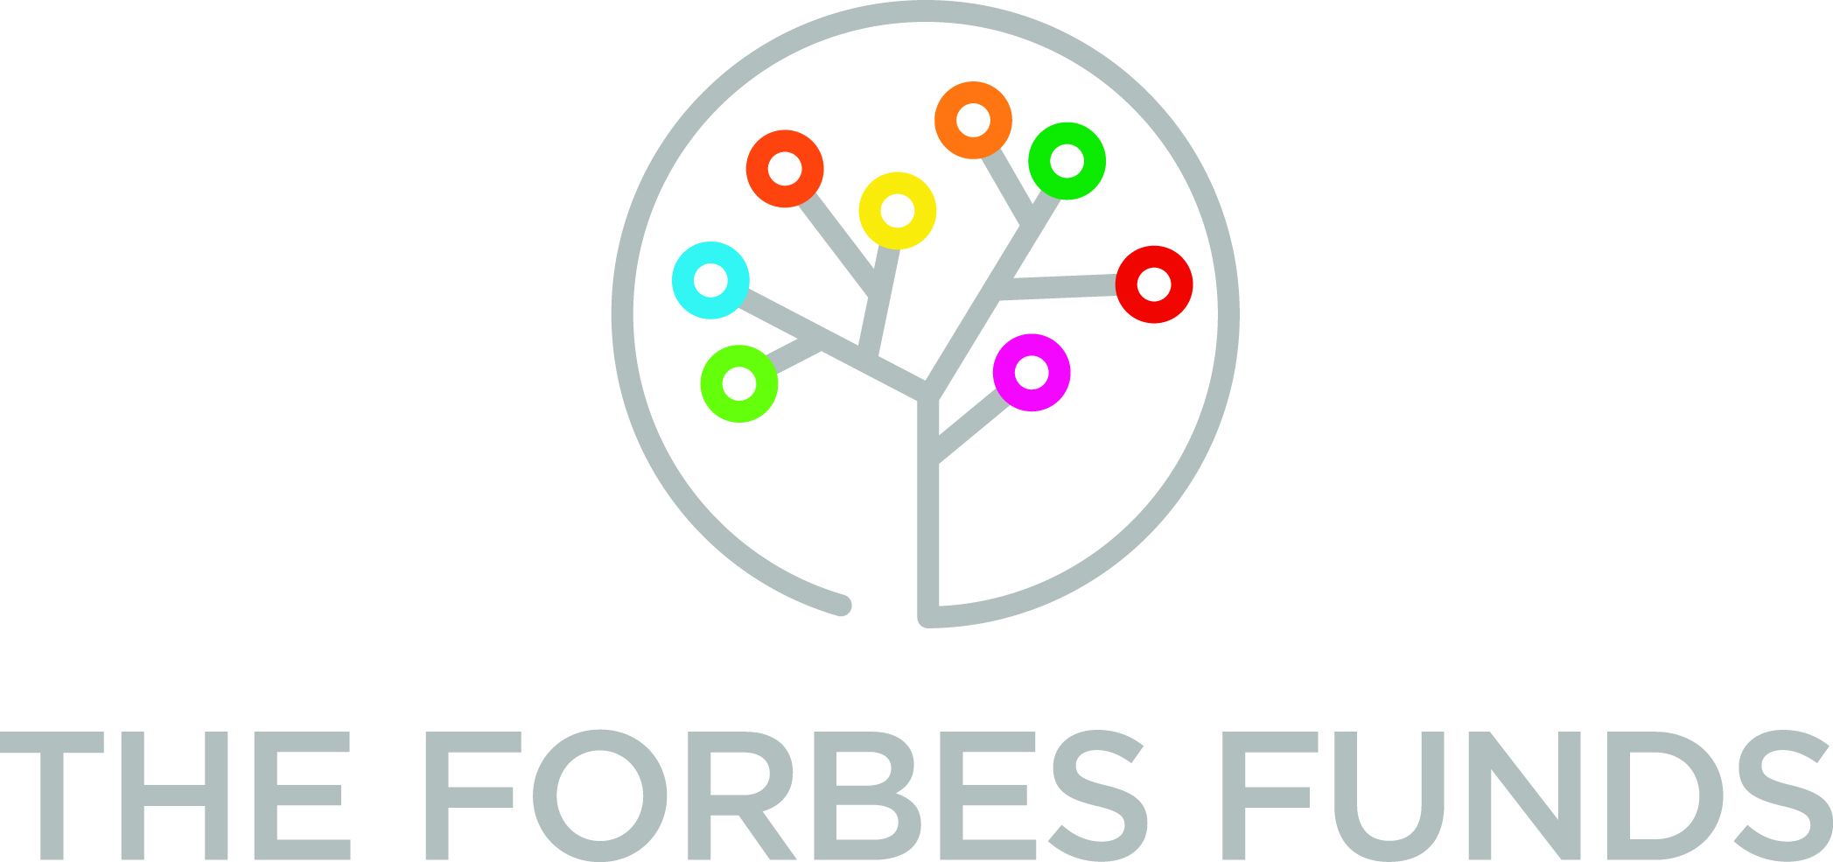

Nonprofit leader Fred Brown to head Forbes Funds
Homewood Children’s Village president cited as capacity builder, innovator
PITTSBURGH, Pa., Dec. 12, 2017 – Fred Brown, a nonprofit executive with 30 years of experience in community building and organizational development in the city’s East End neighborhoods and in Charlotte, N.C., has been appointed president and CEO of The Forbes Funds, an affiliate of The Pittsburgh Foundation. He will take over the top management position Jan. 8.
Brown, 53, who has been president and CEO of the Homewood Children’s Village since 2015, will succeed Kate Dewey, a veteran nonprofit consultant, business owner and corporate executive. She headed the Forbes Funds for the past four years.
The Forbes Funds mission is to provide management assistance and technical expertise to nonprofits, especially those providing human services. Its advocacy arm, the Greater Pittsburgh Nonprofit Partnership, represents 450 members in shaping public policy and researching issues that affect their missions. The overall goal of the Forbes Funds is to ensure a thriving nonprofit sector.
“Fred has deep experience in local nonprofit management that the community would expect to have in a Forbes Funds leader, and we see him bringing so much more to this work, including some exciting systems thinking for improving capacity and strengthening the sector,” Forbes Funds Board Chair Scott Lammie said after announcing the appointment today.
Lammie, who is also senior vice president and chief financial officer of the UPMC Insurance Services Division, headed the eight-member search committee. Brown’s selection concludes a national search that began in August. “We were extremely fortunate to have many superb candidates for this position,” said Lammie. “Fred emerged as the person we believe has the relevant background, experience, and an extraordinary vision to help guide and support our nonprofit sector through this profound and unprecedented period of transformational change, challenge and opportunity.”
Brown said he’s been a longtime admirer of the Forbes Funds work and wants to continue with responsive and innovative programs. His vision, he said, is for the organization to be the essential resource for the nonprofit sector to deliver life-improving social change. “That’s the goal, but my first few months in the position will be dedicated to learning day-to-day responsibilities and having in-depth conversations with Forbes Funds stakeholders. I want to know how they view the Forbes Funds role, and I want to hear ideas they may have to make the organization even more responsive to the increased challenges we all know that the sector will be facing in the next several years.”
Pittsburgh Foundation President and CEO Maxwell King, who also served on the search committee, said he is impressed with Brown’s career concentration in nonprofits directed to working at the neighborhood level to improve life prospects for residents in economically struggling neighborhoods. “As government continues off-loading more and more responsibility for human services and other important supports for vulnerable populations onto the nonprofit community, it is critically important to have a leader who has the head for thinking strategically and the heart to be a champion for what nonprofits accomplish every day. Fred brings both to the position and we’re very excited to have him as part of The Pittsburgh Foundation family.”
In addition to King and Lammie, other Forbes Funds Board members who made up the search committee are Charles “Chip” Burke, chairman of the Grable Foundation; Patrick Dowd, executive director of Allies for Children; Kathy Wilson Humphrey, senior vice chancellor for engagement and secretary to the Board of Trustees, University of Pittsburgh; William Isler, retired president and CEO, the Fred Rogers Co., Brian Parker, partner with the Parker Poe law firm, Charlotte, N.C.; and Nancy Rackoff, member, Eckert Seamans law firm, Pittsburgh.
Dewey’s retirement as president is effective at the end of this month. Next year, she’ll move into a consulting role, focusing on The Forbes Fund’s signature social innovation agenda, which includes the UpPrize Social Innovation Challenge and other projects directed at positioning nonprofits to embrace tomorrow’s opportunities. Dewey will also continue advising nonprofits engaged in progressive strategic restructuring.
# # #
About Fred Brown: A native of Pittsburgh’s Homewood neighborhood, Brown was educated in Pittsburgh’s Public School system and earned undergraduate and graduate degrees at the Indiana University of Pennsylvania and the University of Pittsburgh before moving onto a career track dedicated to improving life prospects for those most in need. His early work included positions as a teacher and probation officer. In 2005, he moved to Charlotte, N.C., to take on education and social work positions, including dean of students at Charlotte-Mecklenburg Schools. In 2009, he returned to Pittsburgh to become associate director of program development at The Kingsley Association, where he concentrated on improving environmental conditions for residents in East End neighborhoods. Among his accomplishments was a partnership with the Larimer Consensus Group to win a $30 million federal Choice Neighborhoods Program grant to build affordable, sustainably designed housing in the neighborhood. Joining the Homewood Children’s Village as president and CEO in August 2015, Brown has focused on two-generation education, the built environment and environmental health as the main assets for improving the lives of Homewood’s children. The broader goal is to reweave the fabric of the community in which they live. The organization serves more than 1,000 youth each year in the neighborhood’s three public schools — Faison, grades K-5; Lincoln, K-5; and Westinghouse, 6-12. The Village provides health, family and educational services to a neighborhood set back by poverty and violence. In the past two years under Brown’s leadership, his team doubled the size of the Village’s budget and its staff. They also increased the number of core partners from 75 to 200 active members.
About The Forbes Funds: As a supporting organization of The Pittsburgh Foundation, the organization focuses on building the management capacity and contributions of community-based nonprofits individually and collectively. It is also the home of The Greater Pittsburgh Nonprofit Partnership, which serves as “The Chamber of Commerce” to 450 area nonprofits. In 2016, The Forbes Funds provided management assistance services to 170 organizations and training opportunities to more than 2,500 nonprofit employees. In 2015, the organization was recognized by The Independent Sector American Express Fellows as a national leader in driving nonprofit community innovation.
#####
For further information contact:
Douglas Root, The Pittsburgh Foundation
412-394-2647
rootd@pghfdn.org

